1. INTRODUCTION

Steganography means covered or hidden writing. The objective of steganography is to send a message through some innocuous carrier. The message to be sent could be a text, an image or it can be an audio file. Steganography techniques prevent the fact that a secret message is being sent at all. Digital stenography allows changes to be made to what are known as digital carriers such as images or sounds. The changes represent the hidden message, but results if successful in no discemible change to the carrier.
Steganography methods combine aspects of digital signal processing, cryptography, statistical communication theory and human perception.
Cryptography and steganography are different. Cryptography techniques can be used to scramble a message so that if it is discovered it cannot be read. If a cryptographic message is discovered it cannot be read. If a cryptographic message is discovered it is generally known to be a piece of hidden information, but it is scrambled so that it is difficult or impossible to understand and de-code.
Steganography hides the very existence of a message. It is a good practice to combine the encryption and steganographic techniques by encrypting a message using steganography. The resulting stego-image can be transmitted without revealing that the secret ingormation has been exchanged. Furthermore, even if an attacker were to defeat the steganographic technique and detect the message from the stego-image ,he would still require the cryptographic decoding key to decipher the encrypted message.
This piece of work discusses about a tool that will work on 8 bit indexed images and is also able to encrypt the secret text using symmetric key cryptography and hide secret text messages inside the color palette of image.

2. SYSTEM REQUIREMENTS & ANALYSIS

2.1.Problem Definition

Steganography is the hiding of a message within another media. A prime candidate for steganography is the use of an image to conceal a hidden ciphered message. Steganography improves encryption and security by creating a medium in which sensitive data can be passed through prying eyes via a file, without alerting anyone that the transmitted file actually contains a message. Steganography should be implemented more in practice today as cyber-terrorism and data-theft becomes an everyday occurrence. Steganography is a relatively old technology, but is still very young in regards to modern usage. With the high security concerns of corporations and individual users alike, the secure transportation of data needs to be a viable option.
There are numerous techniques and methods for steganography, which have been highly researched and used in practice. This shows how well steganography performs in real-world applications in regards to the transportation of sensitive data. The following research uses encoded images and sound files which were presented to test subjects in pairs (one encoded file and its original). This study shows that, even when the original non-encoded file is available for comparison, steganographic files are not discernable by standard observation. This paper also shows how modern steganography detection techniques perform when put to the test.
In general images are the most widespread carrier medium used .In some methods the purpose is to minimize changes to the image and in some the purpose is to store the message in a random way so as to make it more difficult to detect.In some methods more information can be stored by using more than one bit of the colors representing the pixels.This allows more information to be stored but also results in the creation of more new colors and the need to use an image that is comprised of fewer colors to start with.In some methods the process of storing information can result in the production of new cololrs in the image by distorting the original image.

All the evaluation methods required either color reduction of the original images palette or color substitution in the stego image ,they all had their own weaknesses as the stego-image inevitably suffered some distortion from the steganography process.In the case of color reduction based techniques there were strong tell-tail signs in the palette as well.the color rearrangement technique appear to be the most resistant to detection as long as suitable images were chosen.Techniques that attempt to maximize the message size that can store; appear to be the least resistant to detection.
Current techniques for embedding of messages into images fall into three categories:
1)Least-significant Bit embedding (or simple embedding)
2)Transform techniques
3)perceptual masking and filtering techniques.
The proposed method uses indexed (8bits/pixel) bitmaps such as GIF & PNG as the carrier medium to hide secret texts.Secret message is encrypted before hiding .The bits of secret message will be hidden inside the stretched palette of indexed images.Use of both steganography and cryptography techniques result in high secureapplication In an indexed image, colors are stored in a palette which is called color look up table.The indexed image’s palette contains all the colors available for the image.

2.1.1. Scope of the System
Steganography has a wide array of uses. For example, it can be used for digital watermarking, e-commerce, and the transport of sensitive data. Digital watermarking involves embedding hidden watermarks, or identification tokens, into an image or file to show ownership. This is useful for copyrighting digital files that E-commerce allows for an interesting use of steganography.

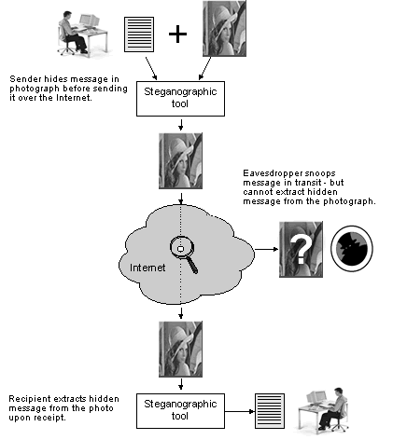
Fig:2.1.1.1. Steganography on the Internet
The transportation of sensitive data is another key use of steganography. A potential problem with cryptography is that eavesdroppers know they have an encrypted message when they see one. Steganography allows (or tries to allow) the transport of sensitive data past eavesdroppers (see Figure 1) – without them knowing any sensitive data has passed them. The idea of using steganography in data transportation can be applied to just about any data transportation method, from E-Mail to images on Internet websites.

2.1.2.Objective of the System
Steganography’s main goal is to avoid detection; to deny the existence of sensitive data inside the cover file. “In steganographic applications there are two levels of security. The first is not allowing an observer to detect the presence of a secret
message. The other is not allowing the attacker to read the original plain message after detecting the presence of secret information.”

2.2.System Overview
2.2.1.Existing System
Since the rise of the Internet is one of the most important factors of information technology and communication has been the security of information. Cryptography was created as a technique for securing the secrecy of communication and many different methods have been developed to encrypt and decrypt data in order to keep the message secret.
2.2.2. Problems with existing system
Unfortunately, embedding the encrypted message in pixel itself will reduce the quality of image, which violates the actual purpose of steganography. So we need a new technique for steganography. The existing system is based on the bit map images and only applicable for those images .The idea algorithm used has also certain restrictions in its usage.
The system uses AES alogorithm for the encryption of the messages which has limitations such as limited key size. The algorithm con be breaked.
The existing system uses only the bitmap images but the proposed system uses the indexed images and also bitmap images.

2.2.3. Proposed System
Our proposed project Steganography technique for palette based images is accomplished through hiding information in the stretched palette. In image steganography the information is hidden exclusively in images.
Our proposed new steganography technique differs from existing in the sense that where general steganography focuses on keeping the contents of a message in pixel’s LSB position, but our new technique focuses on keeping the encrypted message in stretched palette of image. Once the presence of hidden information is revealed or even suspected, the purpose of steganography is partly defeated.
In computing, indexed color is a technique to manage digital images' colors in a limited fashion, in order to save computer's memory and file storage, while speeding up display refresh and telecom transfers. When an image is encoded this way, the color information is not directly carried by the image pixel data, but it is stored into a separate piece of data called a palette: an array of color elements, in which every element, a color, is indexed by its position within the array. This way, each pixel does not contain the full information to represent its color, but only its index into the palette.

2.3 System Architecture
The design phase begins with the requirements specification for the software to be developed. Design is the first step to moving from the problem domain towards the solution domain. Design is essentially the bridge between requirement specification and the final solution the requirements. It is the most critical factor effecting the quality of the software
The design process for software system has two levels
- System Design or Top Level Design
- Detailed Design or Logical Design
2.3.1.System Design
In the system design the focus on the deciding which modules are needed for the system, the specification of these modules and how these modules should be interconnected
2.3.2.Detailed Design
In detailed design the interconnection of the modules or how the specifications of the modules can be satisfied is decided. Some properties for a software system design are
- Verifiability
- Completeness
- Consistency
- Traceability
- Simplicity/Understandability
Steganography can be implemented in various ways. “There are many different kinds of steganography, but all are based on finding unused space on paper, in sound, or in files in which to hide a message.” Many algorithms have been developed to
provide robust and secure steganography – each of which uses different embedding techniques. A common technique is Least-Significant-Bit (LSB) embedding. This technique hides data bits in the last two significant bits of an image pixel. For example, a 500x500 pixel image has 250,000 pixels. If a small 249 character null-terminated ASCII message is embedded, we would need approximate 1992 bits (249 * 8 bits per character) for storage of the string. By breaking up the bit pattern for each character into pairs, we would need 4 pixels per character to store the message by storing 2 bits per pixel. This means only 1000 pixels ((249+1)*4) would need changing in their LSB (from out of a total 250,000). The “+1” in the above calculation comes from the null character used to terminate the string. This has very little effect on the overall image.
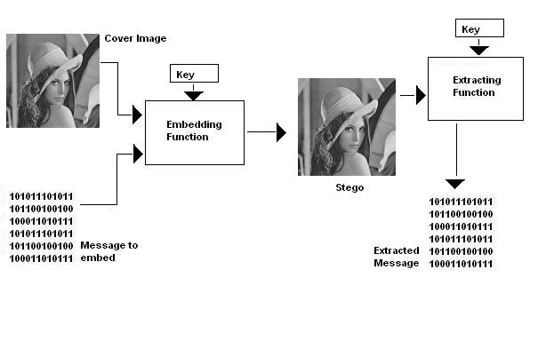
Fig: 2.3.2.1. The steganography process
Figure 2.3.1 shows the steganography process of the cover image being passed into the embedding function with the message to encode – resulting in a steganographic image containing the hidden message. A key is often used to protect the hidden message. This key is usually a password used by the decoding software to unlock the hidden message. Most steganography tools offer encryption of the hidden message before the embedding function is executed, so this key is also used to encrypt and decrypt the message before and after the embedding process

2.4.STRETCHED PALETTE
The methodology uses indexed (8 bits/pixel) bitmaps such as GIF &PNG as the carrier medium to hide secret texts.Secret message is encrypted before hiding.The bits of secret message will be hidden inside the stretched palette of indexed image.Use of both steganography and cryptography techniques result in high secure applications.
In an indexed image,colors are stored in a palette which is called a color look up table.The indexed image’s palette contains all the colors that are available for the image.
There are several palettes:
- The windows system palette
- The Macintosh system palette
- Netscape palette
- Internet explorer palette etc.,
For the new methodology,windows system palette is used BMP,GIF and PNG are some indexed image formats.
As the number of color in the palette is reduced,the image quality also decreases. But addition of new color values to the palette does not affect the quality of the image as long as it doesn’t change the original colors in the palette.This concept is used to hide text in the newly added color values of the palette.
The methodology will stretch the palette of an image by adding two similar,but not identical color values for each color in the palette until it reaches maximum length of color palette or until colors are added to each original color in the palette.
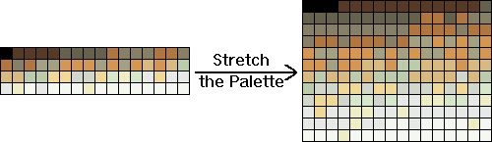

Fig:2.4.1. Stretched Palette
A Stretching palette
Stretching palette is done by following steps:
- For each pixel in original palette,make blue component even & add it to the new color palette.
- Create two new colors similar (not identical) to each color in the palette(brighter or darker copies of the color)
- Make the blue component of the pixel odd
- Add it to the palette
The newe palette size is determined by multiplying the old palette length by 3 times.Maximum palette size can go up to 256 colors.To identify the original colors,the blue component of each pixel is made even.Message bit of”1” in secret text is stored in original color and the message bit of “0” is stored in the added colors.
Un-optimizing palette
While creating the new palette there should be a way to keep a track of the copied and added colors,because later on,when the pixels are changed to reference every color in the new palette,reference ahould be made to identify an original color(even Blue component) to hide a “0”, or a changed color(odd Blue component) to hide a “1”.A hash table is used to map every index from the old palette to the corresponding indeces in the new palette.Original indices are used as the keys and the corresponding new indices are used as the values.

Item | Description
Steganography | Hiding of messages within another media
Plain text | The input to an encryption function or the output of the decryption function
Cipher text | The output of an encryption algorithm. the encrypted form of a message or data
AES | Advanced Encrytion Standard
Encryption | The conversion of plain text or data into unintelligible form by means of a reversible translation, based on a translation table or algorithm
Decryption | The conversion of cipher text into plain text
Stego-image | Image with embedded message

Table 2.4.1 Definitions Acronyms and Abbreviations

3. SYSTEM IMPLEMENTATION
3.1.Overview of Java
Java is platform independent language with a strong set of collections, which contain many utility classes. Java is simple, secure, portable, object Oriented, robust, multithreaded, architecture neutral, interpreted, high performance, distributed and dynamic. Java is easy to learn which makes it simple. The object model in java is simple and easy to extend, while simple types, such as integers are kept as high performance non-objects.
Java is strictly typed language, which allows checking for errors at compile time. Knowing that what you have written will behave in a predictable way under diverse conditions is a key feature of java. Java allocates and de allocates memory by itself. Java provides object oriented exception handling. Java is multi threaded which allows us to write programs that do many things simultaneously. Java is architectural neutral, which allows programs written in java to run on any operating system.
Features of Java:
- Simple
- Secure
- Portable
- Object oriented
- Robust
- Multithreaded
Simple
It is simple for professional programmer to learn & they can use it effectively. If we already know object oriented programming, then learning java is very easy. It inherits syntax from c & object oriented features from c++, so if the user knows c\c++ then it will be a easy way to do effective java programming.

Secure
As we know many people are effected by viral infection when they download an executable file or program. Rather than, virus programs we have malicious programs that can gather private information, such as credit card number, bank account balances & passwords by searching the contents of your computers local file system. Java has a better answer for this effect i.e., “FIREWALL” between networked application and your computer.
Portable
As already we have discussed about compatibility of operating system, computers, chips. In Internet the programs have to be dynamically downloaded to all the various types of platforms. For this purpose java program will generate a byte code (which is not a executable code). Byte code is a highly optimized set of instructions designed to be executed by java run system, which is called as JVM (Java Virtual Machine)
Object-Oriented
Object Oriented Programming is at the core of java. All java programs are object oriented. Object oriented programming organizes a program around its class. Class is at the core of java. It is the logical construct up on which entire java language is built. The class forms the basis for the object oriented programming in java. Class is a template for an object and an object is an instance of class.
Robust
The ability to create robust programs was given a high priority in the design of java. To gain reliability, java restricts you in a few key areas, to force you to find your mistakes early in program development. At the same time, java frees you from having to worry about many of the most common causes of programming errors. Because java is a strictly typed language, it checks your code at Compile time. Java is robust for two reasons; they are Memory management & mishandled exceptional task in traditional programming environments

Portability

For programs to be dynamically downloaded to all the various types of platforms connected to the Internet, some means of generating portable executable code is needed .As you will see, the same mechanism that helps ensure security also helps create portability. Indeed, Java’s solution to these two problems is both elegant and efficient.
Platform Independent:
Platform independence is a way of saying that java is architectural neutral. Java programs do not care on what system they are running on. Most computer software is developed for a specific operating system. Platform independence is the ability of the same program to work on different operating systems. As shown by the use of the applets on the web, a java. Class file of byte code instructions can execute on any platform without any alterations.
The Java API
The Java Application Programming Interface (API) is a set of classes used to develop java programs. These classes are organized in to groups called packages. There are packages for the following tasks.
- Numeric Variable and String Manipulation
- Image Creation and Manipulation.
- Networking
- Applet Programming
- Error Handling
- Security
- Database Access

The JDK
The Java Development Kit is a set of command line tools that can be used to create java programs. The java version 1.2 includes the following tools; a compiler, an interpreter to run compiled java standalone applications, an applet viewer to run java applets, an archive to create compressed archives and other utilities.

Java Virtual Machine (Jvm)

Beyond the language, there is the Java virtual machine. The Java virtual machine is an important element of the Java technology. The virtual machine can be embedded within a web browser or an operating system. Once a piece of Java code is loaded onto a machine, it is verified. As part of the loading process, a class loader is invoked and does byte code verification makes sure that the code that’s has been generated by the compiler will not corrupt the machine that it’s loaded on. Byte code verification takes place at the end of the compilation process to make sure that is all accurate and correct. So byte code verification is integral to the compiling and executing of Java code.
Overall Description
JJJJJJJJJJJJJJa Java SourceJ Java Source
ava Source
Java Source
va Source
Java byte code
JavaVM
Java
.Class
Java Sorce
Java Byte Code
Java VM

Fig:3.1.1.Picture Showing The Development Process Of JAVA Program
Java programming uses to produce byte codes and executes them. The first box indicates that the Java source code is located in a. Java file that is processed with a Java compiler called javac. The Java compiler produces a file called a. class file, which contains the byte code. The. Class file is then loaded across the network or loaded locally on your machine into the execution environment is the Java virtual machine, which interprets and executes the byte code.

3.2.AWT
AWT stands for Abstract Windowing Toolkit. It contains all classes to write the program that interface between the user and different windowing toolkits. You can use the AWT package to develop user interface objects like buttons, checkboxes, radio buttons and menus etc.
3.2.1.Architecture
The AWT provides two levels of APIs:
A general interface between Java and the native system, used for windowing, events, layout managers. This API is at the core of Java GUI programming and is also used by Swing and Java 2D. It contains:
- The interface between the native windowing system and the Java application;
- The core of the GUI event subsystem;
- Several layout managers;
- The interface to input devices such as mouse and keyboard; and
- A java.awt.datatransfer package for use with the Clipboard and Drag and Drop.
A basic set of GUI widgets such as buttons, text boxes, and menus. It also provides the AWT Native Interface, which enables rendering libraries compiled to native code to draw directly to an AWT Canvas object drawing surface.

3.3. Swings
The Swing toolkit includes a rich set of components for building GUIs and adding interactivity to Java applications. Swing includes all the components you would expect from a modern toolkit: table controls, list controls, tree controls, buttons, and labels. Swing is far from a simple component toolkit, however. It includes rich undo support, a highly customizable text package, integrated internationalization and accessibility support. To truly leverage the cross-platform capabilities of the Java platform, Swing supports numerous look and feels, including the ability to create your own look and feel. The ability to create a custom look and feel is made easier with Synth, a look and feel specifically designed to be customized. Swing wouldn't be a component toolkit without the basic user interface primitives such as drag and drop, event handling, customizable painting, and window management.
Swing is part of the Java Foundation Classes (JFC). The JFC also include other features important to a GUI program, such as the ability to add rich graphics functionality and the ability to create a program that can work in different languages and by users with different input devices.
The Swing toolkit includes a rich array of components: from basic components, such as buttons and check boxes, to rich and complex components, such as tables and text. Even deceptively simple components, such as text fields, offer sophisticated functionality, such as formatted text input or password field behavior. There are file browsers and dialogs to suit most needs, and if not, customization is possible. If none of Swing's provided components are exactly what you need, you can leverage the basic Swing component functionality to create your own.
Swing components facilitate efficient graphical user interface (GUI) development. These components are a collection of light weight visual components. Swing components contain a replacement for the heavyweight AWT components as well as complex user-interface components such as trees and tables. Swing is a set of classes that provides more powerful and flexible components than are possible with the AWT. In addition to that the familiar components such as buttons, check box and labels swings supplies several exciting additions including tabbed panes, scroll panes, trees and tables. Even familiar components such as buttons have more capabilities in swing. For example a button may have both an image and text string associated with it. Also the image can be changed as the state of button changes. Unlike AWT components swing components are not implemented by platform specific code instead they are return entirely in JAVA and, therefore, are platform-independent. The term lightweight is used to describe such elements. The number of classes and interfaces in the swing packages is substantial. The Swing architecture is shown in the figure given below:
Application Code

JFC
Java 2D
Swing

Drag & Drop
AWT
Accessibility

Fig:3.3.1.Architecture Of Swings
3.3.1. Advantages of swings
- Wide variety of Components
- Pluggable Look and Feel
- MVC Architecture
- Keystroke Handling
- Action Objects
- Nested containers
- Customized Dialogs
- Compound Borders
- Standard Dialog Classes
- Structured Table and Tree Components
- Powerful Text Manipulation
- Generic Undo Capabilities
- Accessibility Support
The following list shows some of the features of the Swing.

3.3.2. Swing GUI Components
The Swing toolkit includes a rich array of components: from basic components, such as buttons and check boxes, to rich and complex components, such as tables and text. Even deceptively simple components, such as text fields, offer sophisticated functionality, such as formatted text input or password field behavior. There are file browsers and dialogs to suit most needs, and if not, customization is possible. If none of Swing's provided components are exactly what you need, you can leverage the basic Swing component functionality to create our own.
3.3.3. Java 2D API
To make our application stand out; convey information visually; or add figures, images, or animation to your GUI, use the Java 2DTM API. Because Swing is built on the 2D package, it's trivial to make use of 2D within Swing components. Adding images, drop shadows, compositing — it's easy with Java 2D.
Pluggable Look-and-Feel Support
Any program that uses Swing components has a choice of look and feel. The JFC classes shipped by Sun and Apple provide a look and feel that matches that of the platform. The Synth package allows to create our own look and feel. The GTK+ look and feel makes hundreds of existing look and feels available to Swing programs.
Unlike AWT components, swings components are not implemented by platform-specific code. Instead, they are written entirely in Java and, therefore, are platform-independent. The number of classes and interfaces in the swing packages is substantial.
3.3.4. AES algorithm
Rijndael proposal for AES defined a cipher in which the block length and the key length can be independently specified to be 128,192,or 256 bits.The AES algorithm uses the same three key size alternatives but limits the block length to 128 bits.
Rijndal was designed to have the following characteristics:
1)Resistance against all known attacks.
2)Speedand code compactness on a wide range of platforms
3)Design simplicity.
Overall Structure of AES
1)In AES the entire data block is processed parallel during each round using substitutions and permutations.
2)The key that is provided as input is expanded into an array of forty-four 32-bit words.Four distinct words(128 bits) serve as a round key for each round.
3)Four different stages are used , one for permutation and three of substitution :
Substitute bytes: Uses an S-box to perform a byte-by-byte substitution of the block
Shift rows: A simple permutation
Mix Columns: A substitution that makaes use of arithmetic over GF.
Add round key: A simple bitwise XOR of the current block with a portion of the expanded key.
4)The structure is quite simple.For both encryption and decryption, the cipher begins with an Add Round Key stage, followed by nine rounds that each includes all four stages , followed by a tenth round of three stages .
5)Only the Add Round Key stage makes use of the key.For the cipher begins and ends with an Add Round Key stage.Any other stage, applied at the beginning or end, is reversible without knowledge of the key and so would .
6)The Add Round Key stage is , in effect , a form of Vernam cipher and by itself would not be formidable.The other three stages together provide confusion, diffusion, and nonlinearity, but by themselves would provide no security because they do not use the key.We can view the cipher as alternating operations of XOR encryption(Add Round Key) of a block, followed by scrambling of the block,followed by XOR encryption, and so on.This scheme is both efficient and highly secure.
7)Each stage is easily reversible.For the substitute Byte, Shift Row, and Mix Columns stages ,an inverse function is used in the decryption algorithm . For ththe Add Round Key stage, the inverse is achieved by XORing the same round key to the block
8)As with most block ciphers , the decryption algorithm makes use of the expanded key in reverse order.However the dcrytion algorithm is not identical to the encryption algorithm.
9)Once it is established that all four stages are reversible, it is easy to verify that decryption does recover the plaintext.At each horizontal point, State is the same for both encryption and decryption.
10)The final round of both encryption and decryption consists of only three stages.Again this is a consequence of the particular structure of AES and is required to make reversible.

ENCRYPTION
ROUND
PLAIN TEXT
SECRET KEY
KEYROUND0 INPUT
ROUND 0
SUB_BYTES
KEY ROUND 1
ROUND 1

SHIFT_ROWS
....................
EXTENDED_ KEY
MIX_COLUMNS
KEY ROUND Nr-1
ROUND Nr-1
ROUND KEY ROUND KEY
ADD_ ROUND KEY

KEY ROUND Nr OUTPUT
LAST_ROUND Nr
Fig : Encryption

Fig:3.3.2. Encryption process and the steps involved in each round

4.SOFTWARE REQUIREMENTS & SPECIFICATIONS
4.1. User Interface
The system is provided with click and goes type of graphical user interface with buttons and links that can be easily understood by the user. So that the errors in entering the data in appropriate fields can be reduced.

The system is designed in such away that users without any computer knowledge can also use the system with little introduction and training provided in a help file which appears when user click help .In this system we use Swings in Java for developing GUI forms.
4.1.2. Modular Description
Entities involved in steganography in bitmap images are:
1)Encryptor and
2) Decryptor.
1. Encryptor: Encryptor will interact with our system by opening both image and data files and give the key for encrypting and hiding the data in images.
2. Decryptor: Decryptor will interact with our system by opening the stego image and giving the key so that he gets the decrypted data
4.2 Requirements Specification
4.2.1.Hardware Requirements
To run our system the hardware we need is

Processor : PIV

RAM : 512MB

Hard disk : 40GB

4.2.2. Software Requirements
The software necessary for developing the system is:
OS : Windows 98,2000

J2SE Technologies : Swings & AWT

4.3. Functional Requirements
The functional requirements are:
- Encrypting the message
- Applying steganography
  - Stretching Palette
  - Hiding Message in the New Palette
- Extracting a Hidden Message
- Decrypting the message
4.4. Non Functional Requirements
Security: The information that is hidden in the image is secure and can be retrieved only by stegnanalysis
Scalability In the initial stage the system can be used to palette images and later on it can be extended to all types of image as per the requirement.
Response time: The conversion process should be very fast.

5. SYSTEM DESIGN
5.1.About Unified modeling language
In the field of software engineering, the Unified Modeling Language (UML) is a standardized visual specification language for object modeling. UML is a general purpose modeling language that includes a graphical notation used to create an abstract model of a system, referred to as a UML model.
It is very important distinguish between the UML model and the set of diagrams of a system. A diagram is a partial graphical representation of a system’s model. The model also contains a “semantic backplane”- documentation such as written use cases that drive the model elements and diagrams.
UML is officially defined at the Object Management Group (OMG) by the UML Meta model, a Meta-Object Facility meta model (MOF). Like other MOF-based specifications, the UML meta model and UML models may be serialized in XML.UML was designed to specify, visualize, construct, and document software-intensive systems.
UML is not restricted to modeling software. UML is also used for business process modeling, systems engineering modeling and representing organizational structur

es. The Systems Modeling Language is a Domain-Specific Modeling language for systems engineering that is defined as a UML profile.
UML has been a catalyst for the evolution of model-driven technologies, which include model-driven development (MDD), model-driven engineering (MDE) and model-driven architecture(MDA). By establishing an industry consensus on a graphic notation to represent common concepts like classes, components, generalization, aggregation, and behaviors, UML has allowed software developers to concentrate more on design and architecture.
UML is extensible, offering following mechanisms for customization: profiles and stereotype. The semantics of extension by profiles have been improved with the UML revision

5.1.1. Identifying Actors
Actors represent external entities that interact with the system. An actor can be human or an external system during this activity, developers identify the different types of actors that the future system will support.
Actors are roll abstractions and do not directly map to persons. The first step of requirement elicitation is identifying actors. This serves both to define the boundaries of the system and to find all the perspectives form, which the developers need to consider the system. When the system needs to deploy into an existing organization, most actors usually exist before the system is deployed corresponding to roles in the organization.
5.1.2. Use case diagrams

i)Encryptor

Encryptor will interact with our system by opening both image and data files and give the key for encrypting and hiding the data in images.

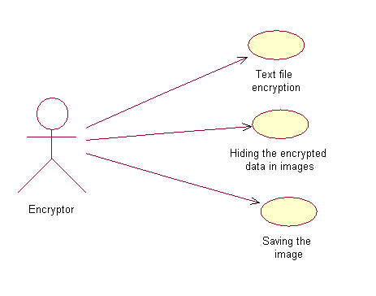
Fig:5.1.2.1 Usecase Diagram For Encryption

2)Decryptor
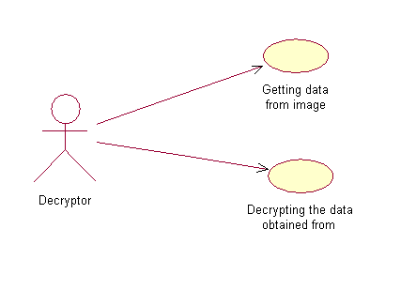
Fig:5.1.2.2 Usecase Diagram For Decryption
Decryptor will interact with our system by opening the stego image and giving the key so that he gets the decryted data.
5.2 Object Models
5.2.1 Class Diagrams
A class diagram is a type of static structure diagram that describes the structure of a system by showing the system's classes, their attributes, and the relationships between the classes.
i) Use case: Hiding the encrypted data in image
The encrypted data present in the file is converted into binary and placed in the least significant bits of each pixel in the image.
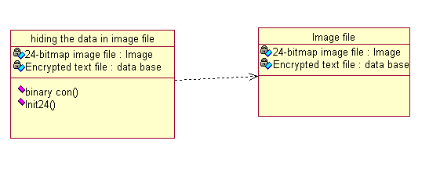
Fig:5.2.1.Hiding the encrypted data in image file
ii) Use case: Saving the image
The image which contains the hidden information is saved by clicking the save button.

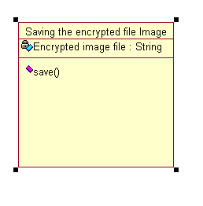
Fig:5.2.2.Save the image
iii) Use case: Getting the data from the image file
The least significant bits of every pixel is taken and they are converted into characters and saved in a file

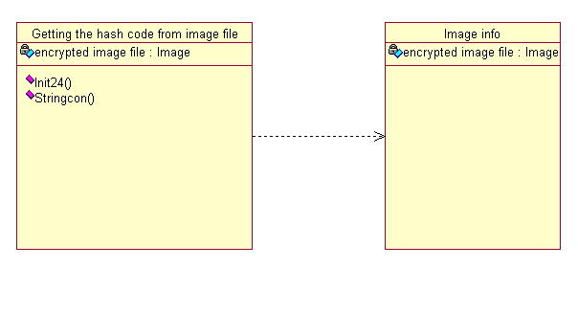
Fig:5.2.3.Getting the data from image file

Decrypting the data obtained from image

The data read from image is passed to AES decryption algorithm. The result is the data is decrypted and saved in a file.
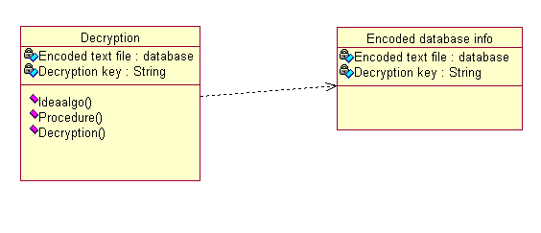
Fig:5.2.4. Decrypting the data obtained from image

5.3.Dynamic Models
5.3.1 Sequence Diagram
A sequence diagram ties uses cases with objects. It shows how the behavior of a use case (or a scenario) is distributed among its participating objects [5].
The columns of a sequence diagram represent the objects that participate in the use case. The leftmost column is actor who initiates the use case. Horizontal arrows,
across columns represent messages, or stimuli, which are from top to bottom. The activation is represented by rectangle from which other message can originate .the length of the represent the time the operation is active.
In our system the encryptor has to first select the text file and he has to give the key. On the basis of the key the data in the text file is encrypted into a cipher text and saved in a file. Then the cipher data in the file is converted into bits and hided in the least significant bits of pixels in the image. Then that file is saved by clicking the save button.
Then he can send the file to any place and to every one. No one can suspect that there is a data in the image because human eye cannot recognize the slight modifications in the image.
In our system the decryptor has to select the image file which contains the data. The decryptor has to give the key. Then the data is read from the least significant bits of pixels and converted into characters and stored in a file. Then that file is given to AES decryption algorithm then we get the original data in a file.

Text file encryption
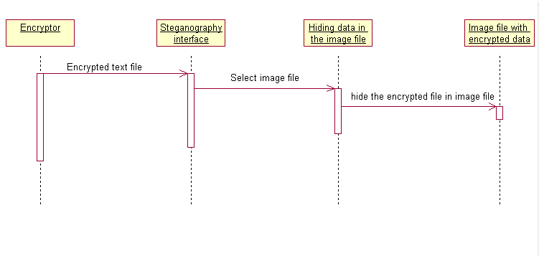
Fig:5.3.2.Sequence Diagram For Hiding the encrypted data into image

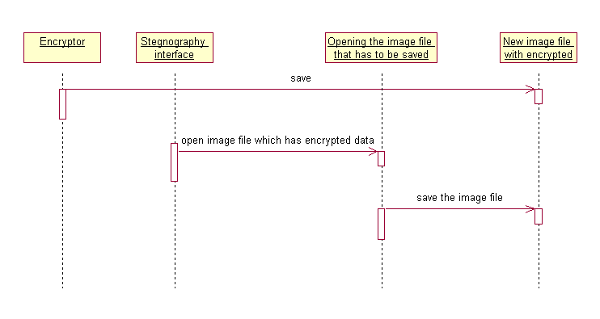

Fig:5.3.3.Sequence Diagram For Save the image

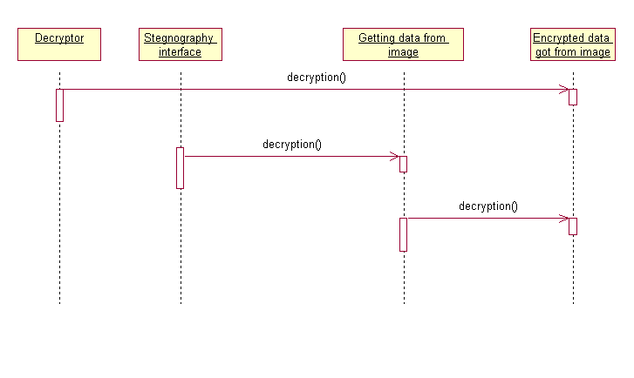
Fig:5.3.4.Sequence Diagram For Getting the data from image

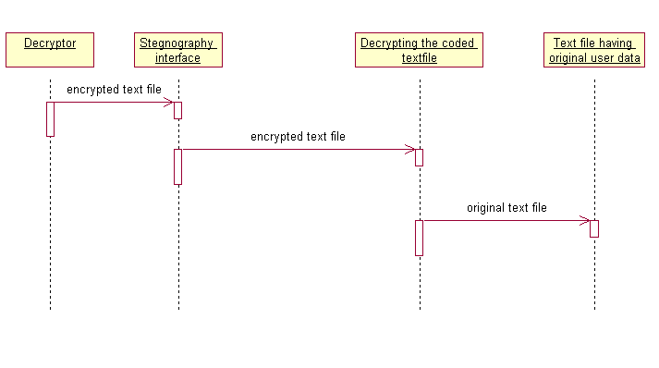

Fig:5.3.5.Sequence Diagram For Data from image

Encrypt the message
Hiding the message in the image
stegnoAnalysis
Decrypt the message
Steg image
Input message
Cipher Text
Cipher Text
Original Message
Secrete key
Img with stretched palette
Stego key
Secrete key

Fig:5.4.1.Architecture Diagram

6. TESTING

Testing is the process used to help identify the correctness completeness, security and quality of developed computer software. Testing is a process of technical investigation, , that is intended to reveal quality-related information about the product with respect to the context in which it is intended to operate. This includes, but is not limited to, the process of executing a program or application with the intent of finding errors.
Software Testing is the process of executing software in a controlled manner; in order to answer the question “Does this software behave as specified?” Software testing is used in association with Verification and Validation.
The aim of testing is often to demonstrate that a program works by showing that it has no errors. The basic purpose of testing phase is to detect the errors that may be present in the program. Hence one should not start testing with the intent of showing that a program works, but the intent should be to show that a program doesn’t work. Testing is the process of executing a program with the intent of finding errors.

6.1.Testing Objectives
1. Testing is a process of executing a program with the intent of finding an error.
2. A good test case is one that has a probability of finding an as yet undiscovered error
3. A successful test is one that uncovers an undercover error.
Testing Principles

- All tests should be traceable to end user requirements.
- Test should be planned long before testing begins.
- Testing should begin on a small scale and progress towards testing in large.
- Exhaustive testing is not possible.
- To be most effective testing should be conducted by a independent third party

6.2 Level of Testing
6.2.1 System Testing
System testing is actually a series of different tests whose primary purpose is to fully exercise the computer-based system. Although each test has a different purpose, all work to that all system element have been properly integrated to perform allocated function.
6.2.2. Code Testing
The goal of the coding or programming phase is to translate the design of the system produced during the design phase into code in a given programming language, which can be executed by a computer and that performs the computation specified by the design.
The coding phase affects both testing and maintenance. The goal of coding is not to reduce the implementation cost but the goal should be to reduce the cost of later phases. In other words the goal is not to simplify the job of programmer. Rather the goal should be to simplify the job of the tester and maintainer.

6.2.3. Coding Approach
There are two major approaches for coding any software system. They are Top-Down approach and bottom up approach.

Bottom-up Approach can best suit for developing the object-oriented systems. During system design phase of reduce the complexity. We decompose the system into an appropriate number of subsystems, for which objects can be modeled independently. These objects exhibit the way the subsystems perform their operations.
Once objects have been modeled they are implemented by means of coding. Even though related to the same system as the objects are implemented of each other the Bottom-Up approach is more suitable for coding these objects.
In this approach, we first do the coding of objects independently and then we integrate these modules into one system to which they belong.

6.2.4. Information Handling
Any software system require some amount of information during its operation selection of appropriate data structures can help us to produce the code so that objects of the system can better operate with the available information decreased complexity.

6.2.5. Programming Style
Programming style deals with act of rules that a programmer has to follow so that the characteristics of coding such as Trace ability, Understandability, Modifiability, and Extensibility can be satisfied.
In the current system we followed the coding rules for naming the variables and methods. As part of coding internal documentation is also provided that help the readers to better understand the code.
6.2.6.Verification and Validation
- Verification is the process of checking the product built is right.
- Validation is the process of checking weather the right product is built.
During the Development of the system, coding for the object has been thoroughly verified from different aspects regarding their design, in the way they are integrated and
etc. The various techniques that have been followed for validation discussed in testing the current system, coded in Java.

6.3. Types of Testing
- Unit Testing
Unit testing focuses verification efforts on the smallest unit of the software design, the module. This is also known as “Module Testing”. The modules are tested separately.
- Integration Testing
Data can be grossed across an interface; one module can have adverse efforts on another. Integration testing is systematic testing for construction the program structure while at the same time conducting tests to uncover errors associated with in the interface.
- Validation Testing
At the conclusion of integration testing software is completely assembled as a package, interfacing errors have been uncovered and corrected and a final series of software tests begins, validation test begins. Validation test can be defined in many ways. But the simple definition is that validation succeeds when the software function in a manner that can reasonably expected by the customer. After validation test has been conducted one of two possible conditions exists.
- Output Testing
After performing validation testing, the next step is output testing of the proposed system since no system could be useful if it does not produce the required
output in the specified format. Asking the users about the format required by them tests the outputs generated by the system under consideration.
- User Acceptance Testing
User acceptance of a system is the key factor of the success of any system. The system under study is tested for the user acceptance by constantly keeping in touch with the prospective system users at the time of developing and making changes wherever required.

6.4.Test Cases

Test Case ID | Test case Name | Test Case Description | Expected Value | Actual Value | Result
1 | Reading the Text file | The input is to be taken from the Text file | By using a file chooser window an image is to be selected | By using a file chooser window an image is to be selected | pass
2 | Selecting the image | Select the image file in which data is to hidden | By using a file chooser window an image is to be selected | By using a file chooser window an image is to be selected | pass
3 | Taking the secret key | By using a dialog box secret key is to be given | A dialog box will be opened and the key will be readed | A dialog box will be opened and the key will be readed | pass
4 | Save the decrypted image | The image which contains the decrypted data should be saved | A file chooser window is opened and path is specified in it | A file chooser window is opened and path is specified in it | pass
5 | Decrypt the image | The image that is saved is decrypted | A file chooser window is opened to specify the path | A file chooser window is opened to specify the path | pass
6 | Result the secret message | The secret message is Will be displayed | The secret message is Will be displayed in a text file | The secret message is Will be displayed in a text file | pass

7. SCREEN SHOTS

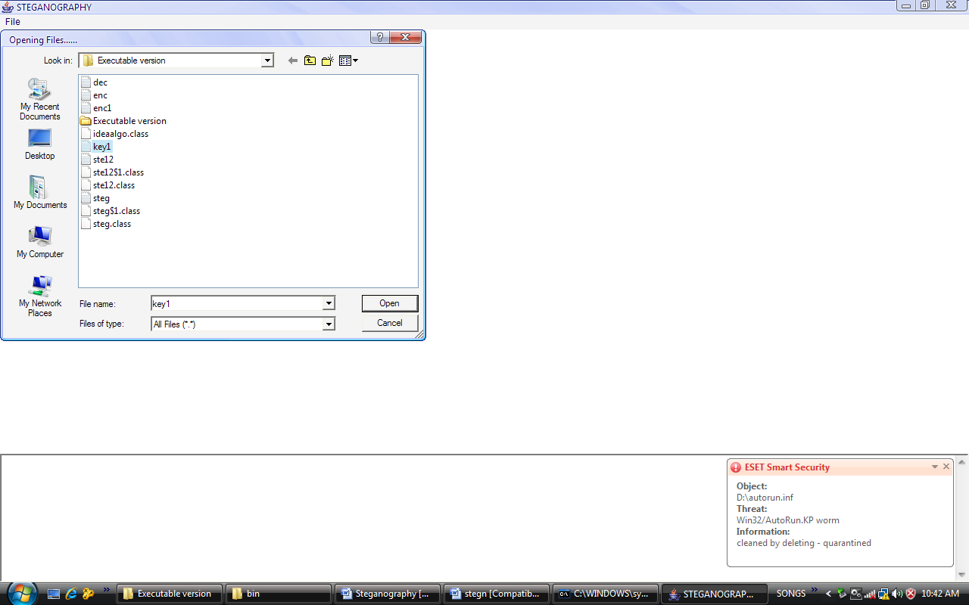

Fig:7.1:Selecting a Text File

At first the encryptor must select the text file . The selection process is as shown in the above figure7.1.

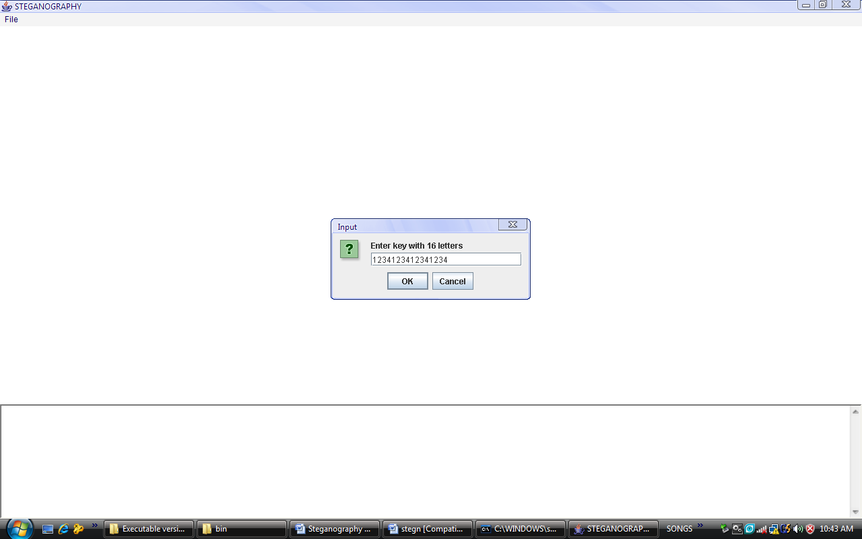

Fig:7.2. Entering The Key

After selecting the text file the encryptor must enter the secret key . Then the AES algorithm using the key encrypts the data in the text file. The key must be of 16 characters which is as shown in the figure 7.2

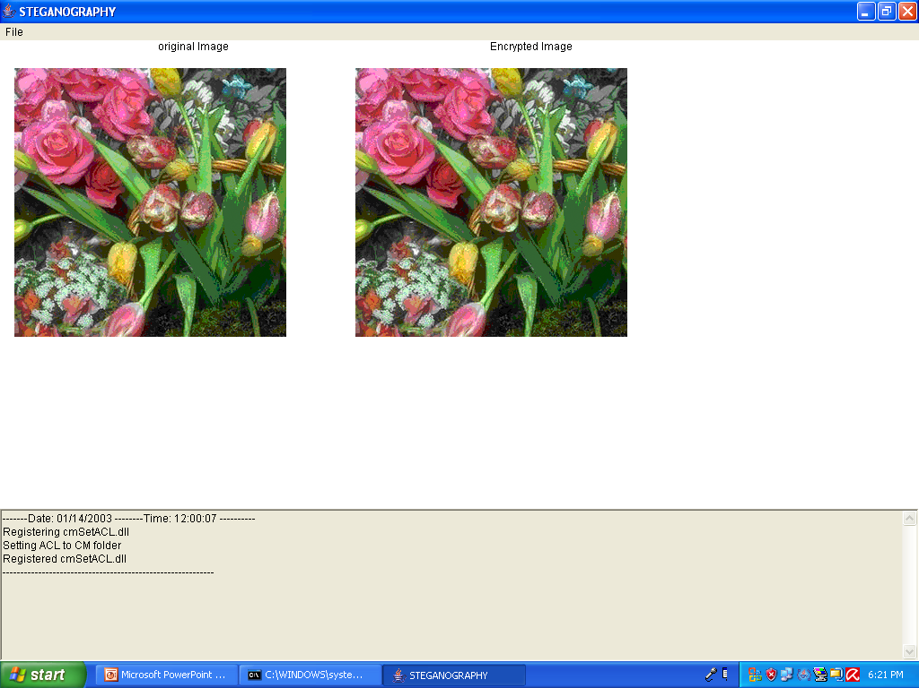

Fig:7.3:Selecting An Image File

After selecting the text file and entering the key the data in text file is displayed in the text box. Then the encryptor must select the bitmap image file. After selecting image both original and encrypted image will be displayed as shown in the figure.7.3.

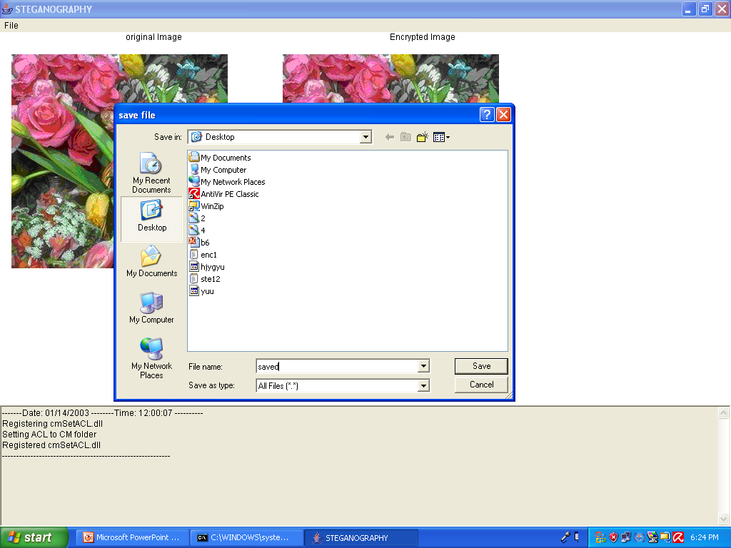

Fig:7.4:Save The Image File

The encrypted image must be saved. The saving process is as shown
in the figure 7.4

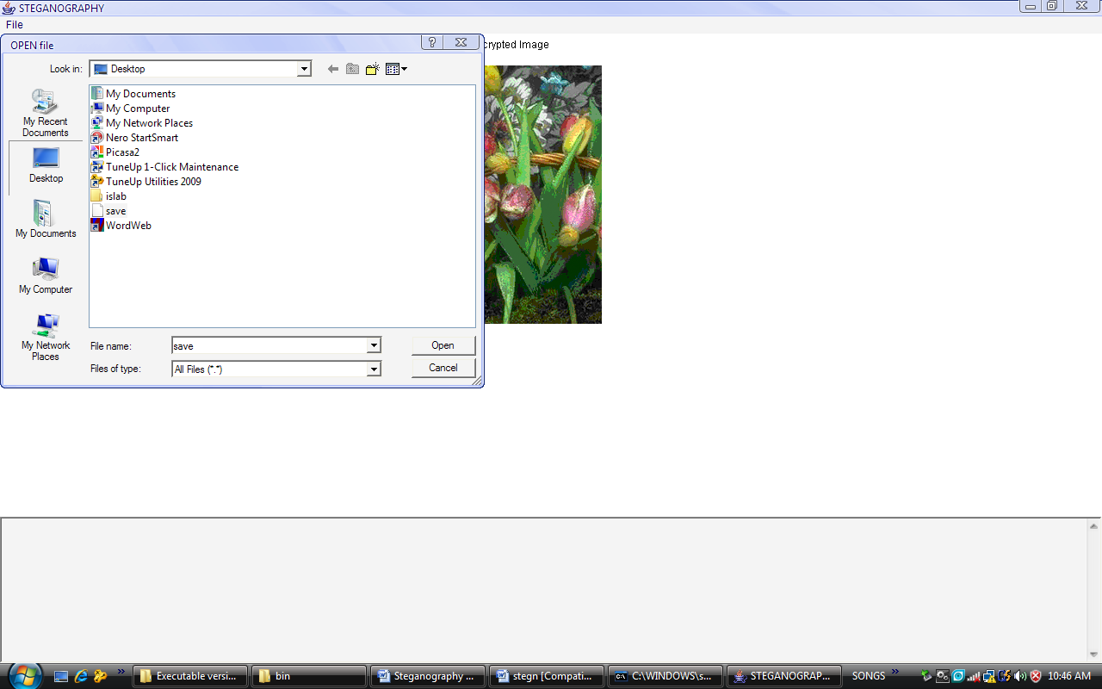

Fig:7.5: Selecting The Encrypted Image

The decryptor must select the encrypted image. The decryptor selects the image by clicking the decrypt button fig 7.5

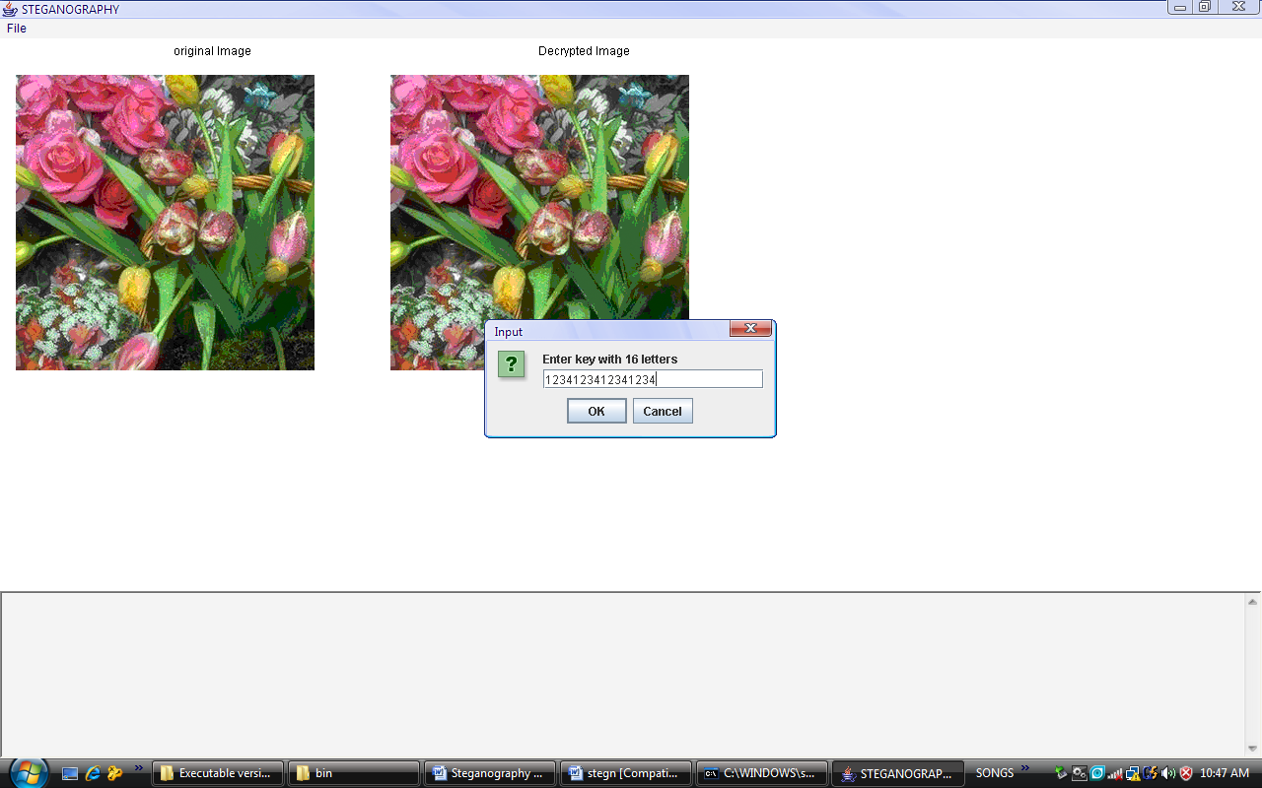

Fig:7.6. Entering The Key

The decryptor must enter the secret key to decrypt the data obtained from the image. The key must be of 16 . bit length fig 7.6

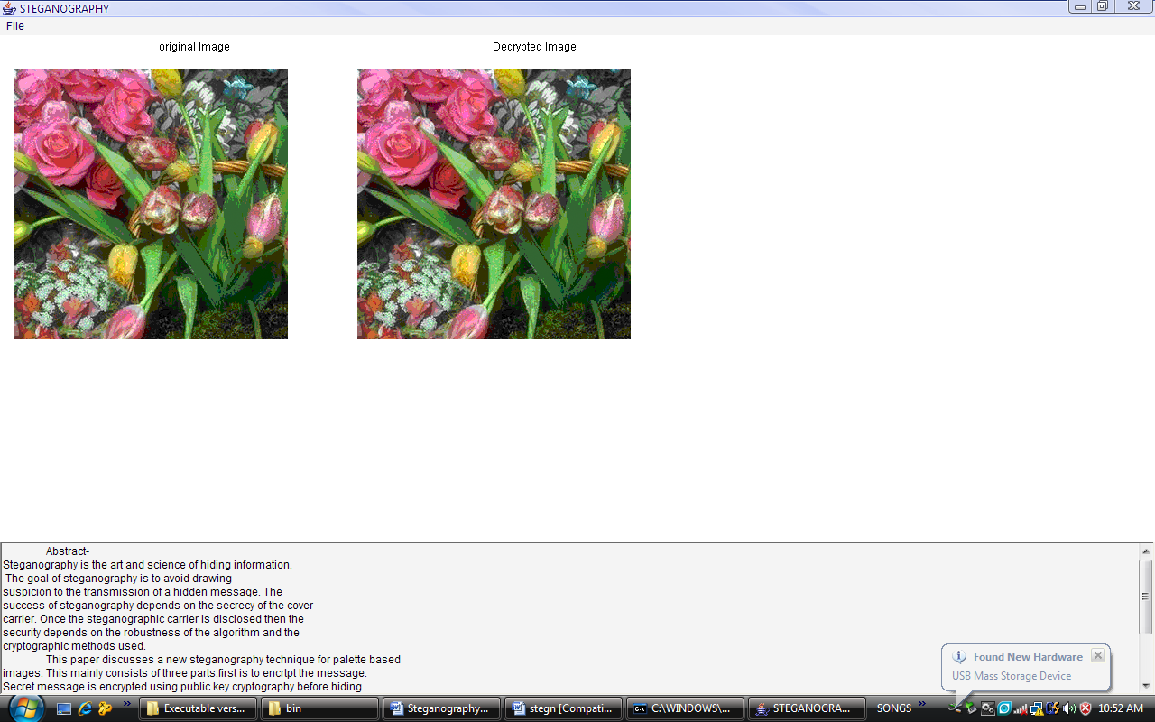

Fig:7.7. Decrypted Image

After entering the key the idea decryption algorithm decrypts the data and it is shown in the text box at the bottom of the screen above fig 7.7

8. CONCLUSION & FUTURE ENHANCEMENT

Steganography improves encryption and security by creating a medium in which sensitive data can be passed through prying eyes via a file, without alerting anyone that the transmitted file actually contains a message. Steganography should be implemented more in practice today as cyber-terrorism and data-theft becomes an everyday occurrence.
With the technological advancement in the field of steganography every day there is a great scope for further development.
Some of the expected future enhancements would be as follows :
- The system could be enhanced to support all possible image file formats.
- The encryption algorithm could be increased by using 128 bit key to 512 bit key for encryption.
- Other algorithms such as Triple DES, IDEA etc could be implemented.
- Public key cryptography system suggests a very secured and convenient way of communicating. This can easily be incorporated as an option to the encryption .That is, algorithms such as RSA could be implemented as an option for encryption .Since private key cryptography needs some secured channel to establish the key. This makes the public key cryptography to be an added advantage over the private key cryptography because public key cryptography do not need to have a secured channel to establish a key supposing in the case of strangers

9.BIBILOGRAPHY

- “The Complete Reference Java2 “ Fourth edition TMH., 2001,
Herbert schildt..
- “The Java Almanic an advanced programmers guide” 2003.
Fouroj J.
- . “Applied Cryptography” second edition. 2002.
Bruce Schneier.
- . “Network Security Essentials: Applications and standards” 2000.
William Stallings.
- .” Software Engineering “ 6th edition-2001
Ian Sommerville.
- “Cryptography and Network Security”, Pearson Education, 1999.

William Stallings.

SAMPLE CODE
DECRYPION
void decryption(String file)
{
try
{
fdec=new DataOutputStream(new FileOutputStream("dec.txt"));
fenc1=new FileInputStream(file);
}
catch(Exception e)
{
System.out.println(e+"ravikrishna");
}
try
{
size=fenc1.available();
np=0;
p=size%8;
if(p!=0)
np=8-p;
size+=np;
if(p==0)
nl=size/8;
else
nl=size/8+1;
buf1=new byte[size+10];
buf=new byte[8];
fenc1.read(buf1);
mark=-8;
int arr[]=new int [8];
for(k1=0;k1<nl;k1++)
{
mark+=8;
for(int k2=0;k2<8;k2++)
buf[k2]=buf1[mark+k2];
for(int k2=0;k2<8;k2++)
{
arr[k2]=0;
if(buf[k2]>=0)
arr[k2]=buf[k2];
else
arr[k2]=buf[k2]+256;
}
j1=0;i1=0;
while( i1<=3)
{
if((j1+1)%2==0)
{
x[i1]|=arr[j1]; // dividing 64 bit cypher block into four 16 bit registers
i1++;
}
else
{
x[i1]=arr[j1];
x[i1]<<=8;
}
j1++;
}
for(int t=0;t<4;t++)
{
ft1 =x[t]&255;
ft=x[t]>>8;
}
step1=mul( x[0] , minverse( z[48] ));
step2=( x[1] + ainverse( z[49] )) % 65536;
step3=( x[2] + ainverse( z[50] )) % 65536;
step4=mul( x[3] , minverse( z[51] ));
step5=step1^step3;
step6=step2^step4;
step7=mul(step5,z[46]);
step8=(step6+step7)%65536;
step9=mul(step8,z[47]);
step10=(step7+step9)%65536;
step11=step1^step9;
step12=step3^step9;
step13=step2^step10;
step14=step4^step10;
x[0]=step11;
x[1]=step12;
x[2]=step13;
x[3]=step14;
// 2nd round
int j2=40;
for(j1=1;j1<=7;j1++)
{
step1=mul( x[0] , minverse( z[j2+2] ));
step2=( x[1] + ainverse( z[j2+4] )) % 65536;
step3=( x[2] + ainverse( z[j2+3] )) % 65536;
t=step2;
step2=step3;
step3=t;
step4=mul( x[3] , minverse( z[j2+5] ));
step5=step1^step3;
step6=step2^step4;
step7=mul(step5,z[j2+0]);
step8=(step6+step7)%65536;
step9=mul(step8,z[j2+1]);
step10=(step7+step9)%65536;
step11=step1^step9;
step12=step3^step9;
step13=step2^step10;
step14=step4^step10;
x[0]=step11;
x[1]=step12;
x[2]=step13;
x[3]=step14;
j2=j2-6;
}
x[0]=mul(x[0],minverse(z[0]));
x[1]=(x[1]+ainverse(z[2]))%65536;
x[2]=(x[2]+ainverse(z[1]))%65536;
x[3]=mul(x[3],minverse(z[3]));
t=x[1];
x[1]=x[2];
x[2]=t;
for(int t=0;t<4;t++)
{
ft1 =x[t]&255;
ft=x[t]>>8;
fdec.write((char)ft);
fdec.write((char)ft1);
}
}
}
catch(Exception e)
{
System.out.println(e+"ergeg");
}
}
int mul( int a , int b)
{
double c,d;
if (a==0)
c=65536;
if(b==0)
d=65536;
c=(double)a;
d=(double)b;
a= (int)((c*d)%65537);
return a;
}
int minverse(int z)
{
int to,t1;
int q,y;
if(z<=1)
return z;
t1=0x10001/z;
y=0x10001%z;
if(y==1)
return (0xffff&(1-t1));
to=1;
do
{
q=z/y;
z=z%y;
to+=q*t1;
if(z==1)
return to;
q=y/z;
y=y%z;
t1+=q*to;
}
while(y!=1);
return (0xffff&(1-t1));
}
int ainverse(int z)
{
return (65536-z);
}
}

ENCRYPTION
void encrypt()
{
try
{
size=fin.available();
p=size%8;
if(p!=0)
np=8-p;
size+=np;
if(p==0)
nl=size/8;
else
nl=size/8+1;
buf=new byte[8];
buf1=new byte[size+10];
fin.read(buf1);
int enc[]=new int[size];
mark=-8;
k2=0;
for(k=0;k<nl;k++)
{
mark+=8;
for(int k1=0;k1<8;k1++)
buf[k1]=buf1[mark+k1];
i=0;
for(i=0;i<4;i++)
x[i]=0;
j1=0;i1=0;
while( i1<=3)
{
if((j1+1)%2==0)
{
x[i1]|=buf[j1]; // dividing 64 bit cypher block into four 16 bit registers
i1++;
}
else
{
x[i1]=buf[j1];
x[i1]<<=8;
}
j1++;
}
// 7 rounds and 14 steps
for(i=0 ; i <48 ; )
{
step1=mul(x[0],z[i+0]);
step2=(x[1]+z[i+1])%65536;
step3=(x[2]+z[i+2])%65536;
step4=mul(x[3],z[i+3]);
step5=step1^step3;
step6=step2^step4;
step7=mul(step5,z[i+4]);
step8=(step6+step7)%65536;
step9=mul(step8,z[i+5]);
step10=(step7+step9)%65536;
step11=step1^step9;
step12=step3^step9;
step13=step2^step10;
step14=step4^step10;
x[0]=step11;
x[1]=step13;
x[2]=step12;
x[3]=step14;
i=i+6;
}
x[0]=mul(x[0],z[48]);
x[1]=(x[1]+z[49])%65536;
x[2]=(x[2]+z[50])%65536;
x[3]=mul(x[3],z[51]);
for(int t=0;t<4;t++)
{
ft1 =x[t]&255;
ft=x[t]>>8;
fenc.write((char)ft);
fenc.write((char)ft1);
}
}
fin.close();
}
catch(Exception e)
{
System.out.println(e);
}
}

